*Strategies for Improving Graduation Rate at Cal State LA*

project Management plan

Version <1.0>

01/13/2018

VERSION HISTORY

|  |  |  |  |  |  |
| --- | --- | --- | --- | --- | --- |
| **Version #** | **Implemented**  **By** | **Revision**  **Date** | **Approved**  **By** | **Approval**  **Date** | **Reason** |
| 1.0 | Tanmai Aurangabadkar | 01/13/2018 | Dr. Arun Aryal |  |  |
|  | Era Singh Kajal |  |  |  |  |
|  | Rohit Tiwari |  |  |  |  |
|  | Sohong Chakraborty |  |  |  |  |
|  | Abhishek Shah |  |  |  |  |

TABLE OF CONTENTS

1. Introduction 3

1.1 Purpose of Project Management Plan 3

2. Executive Summary of Project Charter 3

2.1 Assumptions/Constraints 3

3. Scope Management 3

3.1 Work Breakdown Structure 4

3.2 Deployment Plan 4

Deployment Strategy 5

3.3 Change Control Management 6

4. Schedule/Time Management 6

4.1 Milestones 6

4.2 Project Schedule 7

5. Cost/Budget Management 8

6. Quality Management 9

7. Human Resource Management 9

8. Communications Management 11

8.1 Communication Matrix 11

9. Risk Management 13

9.1 Risk Response Plan 14

Appendix A: Project Management Plan Approval 15

APPENDIX B: REFERENCES 16

# 

# Introduction

## Purpose of Project Management Plan

The intended audience of the Strategies for Improving Graduation Rate at Cal State LA areall project stakeholders including the project sponsor, director, project manager, quality manager, system developer and business analyst.

The purpose of **Strategies for Improving Graduation Rate at Cal State LA** project is to highlight the long-term benefits of higher graduation rate at Cal State LA. It also identifies few ways to help Cal State LA students to connect with the university. In addition, it analyses causes for low graduation rate, and solutions to overcome this problem.

24/7 online mentoring portal can be one of the critical components in helping Cal State LA students to enhance their academic performance and eventually increase the graduation rate of the university.

# Executive Summary of Project Charter

Main aim of our project is to increase the graduation rate of Cal State LA students for which we are developing an online mentoring system. The key advantage of online counselling is the convenience that it provides for the students to learn at their own pace without any restrictions and compulsion of time as needed. The major success indicators for proper functioning of the project are based on the following factors:

1. Availability of mentors
2. Steady internet connection
3. Maximum number of students attending the online counselling session
4. Portal should support all the features.

## Assumptions/Constraints

## Assumptions

1. The data of graduation rate is free of any flaws. If the data turns out to be inaccurate then the analysis for this business case will turn out to be unsuccessful.

2. E-mentoring needs both mentors and mentees to have easy access to technology, such as a computer or lap top, a reliable Internet connection, and a medium of communication, like a mentoring workbench, email service, or video conferencing program. Usage of these components is flourishing around the world, but their necessity can still present a threat.

**CONSTRAINTS**

1. Detailed Data: Unavailability of detailed data of graduation rate of students might affect the formulation of strategy.

2. Internet connection: Due to the geographical location, slow internet connection can be observed.

3. Predetermined Budget: A predetermined budget will restrict any changes in later phase.

# Scope Management

Scope Management is the collection of processes which ensure that the project includes all the work required to complete it while excluding all work which is not necessary to complete it. To manage the project successfully, members in our project team have been assigned different roles and responsibilities. Online academic counselling portal allows advisors and participants (students) to make connections around the world where their interactions can take place frequently and easily, at the click of a few buttons. Eventually, this will help in increasing the overall graduation rate of the Cal State LA.

## Work Breakdown Structure

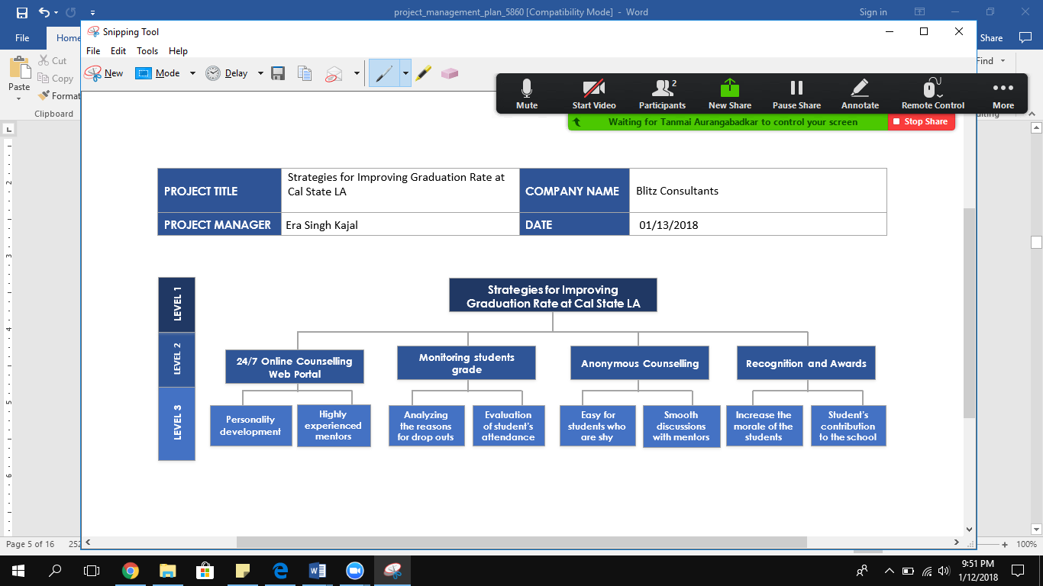

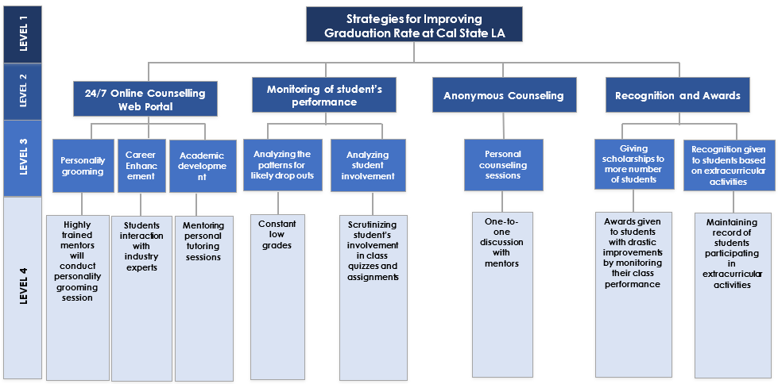

Figure 1: Work breakdown structure

## Deployment Plan

The core work streams and associated milestones:

The online web portal will be more than just a website where students will get academic help. The portal will keep track of academic performances of every student by importing data from the college online portal called Moodle. This will help the counsellors to identify the likely drop-out candidates. Students just need to sign up to this portal using their college id and their password.

The portal will have provision for group as well as individual counselling. Group counselling focusses on the balance between academic and professional life. The anonymous counselling sessions will be more focused on personal problems where students can seek help under the bond of secrecy where no information will be divulged under no circumstances. This may help the students to become more comfortable with the counselors.

The fundamental benefit of online counselling is the convenience that it provides for the students to learn at their own speed without any restrictions and compulsion of time as needed. E-mentoring provides flexibility to the students where they can access the material available online and at any time of the day.

Scholarships and Recognitions to be given to students for their consistent performance in class. This will inspire students and help in achieving their future goals.

# Deployment Strategy

|  |  |  |  |
| --- | --- | --- | --- |
| Deployment Overview | | | |
| Number of Sites or Release Recipients | **Target Deployments** | **Target Group** | Scheduled Dates | |
| The deployment will include integration of an online portal to the existing CSULA portal. Thus, it is available to all students just by logging in. | Initial Deployment-  Prototype of the system | CSULA Portal | 01/2018 | |
| General Availability Release-  Complete counselling website | CSULA Portal | 02/2018 | |
| Deployment Approach | | | | |
| Description | | | | |
| The deployment approach we followed for this system is phased approach. Constant changes & corrections can be made, and it is cost effective. | | | | |
| Benefits (Tangible and Intangible) and Risks | | | | |
| The sole benefit of this system is to improve and increase the graduation rate of CSULA, which can be achieved. | | | | |
| Assumptions and Risks | | | | |
| Assumptions | | | | |
| 1. The graduation data rate is free of any irregularities. If this data turns out to be incorrect then the analysis for this business case will turn out to be futile. 2. E-mentoring needs both mentors and mentees to have easy access to technology, such as a computer or lap top, a reliable Internet connection, and a medium of communication, like a mentoring workbench, email service, or video conferencing program. Usage of these components is flourishing around the world, but their necessity can still present a challenge. | | | | |
| Risks | | | | |
| 1. Unstable economic growth- International students who come from various parts of the globe are charged fees more than 3 times the domestic students, which is way too heavy to pockets of most students. 2. Change in student enrollment plan- Drop-out rate is unusual every year. | | | | |

## Change Control Management

**Scope Change Request Form**

**Requestor Name:** Rohit Tiwari **Request Date:** 01/15/2018

**Request Title:** Integration of new online portal on CSULA website

**Request Number:** 001

**Request Description:** We integrated our new online portal with the existing CSULA portal. The idea of our new online portal is to provide online mentor session to those students who we think are about to drop out before their graduation.

**Justification:** This new program will assist students and encourage them not to drop out just by following the mentor’s shown direction. Less students dropping out will result into increase in the graduation rate.

|  |  |  |
| --- | --- | --- |
| **Impacts** | **Alternative 1** | **Alternative 2** |
| Scope | Conducting online surveys for students | In-person interaction with mentors |
| Schedule | 3-4 weeks | As per mentee’s requirement |
| Resources required | 5 employees | 1 mentor |
| Cost | 160 hours x $15/ hour x 5 = $12,000 | $80 per hour |

Table 1: Possible Alternatives

Recommendation: The new online system will help extensively in addition to the existing portal.

Authorized By: CSULA

Date: 01/10/2018

# Schedule/Time Management

## Milestones

01/20/2018

01/28/2018

02/10/2018

03/4/2018

System Development

Completed

Developed Prototype

Requirements Analysis

Completed

Project Plan Completed

The table below lists the milestones for this project, along with their estimated completion timeframe.

| **Milestones** | **Estimated Completion Timeframe** |
| --- | --- |
| Project planned, and requirement analysis completed | Two weeks after project planning is done |
| Development of prototype | Two weeks after the completion of requirement analysis |
| System development completed | Three weeks after the completion of prototype |

Table 2: Milestones of a project

## Project Schedule

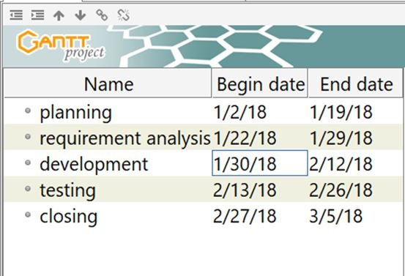



# Cost/Budget Management

## The main source of funding is to be provided by Cal State, LA and the school being a public university may get government grant as well. The students benefitting from the program will also be asked to form a strong alumni network and pitch in some donations as and when required by the college.

## 5.1 ESTIMATES

|  |  |  |  |  |  |  |
| --- | --- | --- | --- | --- | --- | --- |
| **Object Code** | **Budget Item** | **Qtr1** | **Qtr2** | **Qtr3** | **Qtr4** | **Total** |
| 11 | Personnel | $5000 x 3 employees x 3 months  =$45000 | $5000 x 1 employee x 3 months  = $15000 | $5000 x 1 employee x 3 months  = $15000 | $5000 x 1 employee x 3 months  = $15000 | $90,000 |
| 20 | Contractual Service | $8000 | $2000 | $2000 | $2000 | $14000 |
| 26 | Supplies (Awards) | $2000 | $2000 | $2000 | $2000 | $8000 |
|  | **Total** | **$55000** | **$19000** | **$19000** | **$19000** | **$112000** |

Table 3: Estimates

# Quality Management

Quality Management describes the method the organization uses for managing quality throughout the project’s life cycle. Quality must always be planned into a project to prevent irrelevant rework, waste, cost, and time.

# Human Resource Management

Human resources management plan aids in the management of the project’s human resource activities throughout the project until its completion.  
The purpose of the human resources management plan is to achieve project success by ensuring the appropriate human resources are acquired with the necessary skills, resources are trained if any gaps in skills are identified, team building strategies are clearly defined, and team activities are effectively managed.

These are the roles and responsibilities of our project team members.

| **Name** | **Project Role** | **Project Responsibilities** |
| --- | --- | --- |
| Blitz Consultants | Sponsor | Blitz’s vision is to offer strategies to develop academic skills, behaviors, and inculcate professional attitude in students by providing online mentoring system. It has enabled students to improve their grades, attendance and helped them to connect with various university programs. |
| Rohit Tiwari | Project Director | As the most responsible authority over a project, this individual manages IT team members and allocates the available resources. He strategically oversees, monitors and manages online mentoring system from an executive level. |
| Era Singh Kajal | Project Manager | She is responsible for the planning and monitoring of online mentoring system. She manages the project risks and maintains reports based on the project progress. |
| Tanmai Aurangabadkar | Quality Manager | She is responsible to conduct periodic management review meetings. Also, she ensures the evaluation of the working of the system. |
| Sohong Chakraborty | System Developer | His role is to design, install and maintain the software systems. He consults with the future users to determine what they expect the system to do. |
| Abhishek Shah | Business Analyst | He acts as a mediator between the customers (students) and the project team.  His primary responsibility is requirement management and communication with customers. |

Table 4: Roles and Responsibilities of the project members

The following RACI chart shows the relationship between project tasks and team members. Any proposed changes to project responsibilities must be reviewed and approved by the project manager. Changes will be proposed in accordance with the project’s change control process. As changes are made all project documents will be updated and redistributed accordingly.

Key:

R – Responsible for completing the work

A – Accountable for ensuring task completion/sign off

C – Consulted before any decisions are made

I – Informed of when an action/decision has been made

|  |  |  |  |  |  |
| --- | --- | --- | --- | --- | --- |
|  | Project Director | Project Manager | Quality Manager | System Developer | Business Analyst |
| Project Plan | A | A | R | C | C |
| Requirement Analysis | A | A | C | C | C |
| Developing Prototype | A | A | I | I | C |
| Software Testing | A | A | C | I | I |
| Implementation | A | A | R | C | C |

Table 5: RACI Chart

# 7.1 Staffing Management

The Staffing Management Plan details the project’s human resources requirements and how those requirements will be fulfilled. The Staffing Management Plan includes several sections:

* **Project Roles and Responsibilities** – summarizes the responsibilities for each role required to conduct the project work
* **Project Staffing Estimates** – identifies estimated staffing requirements
* **Acquisition Strategy** –describes when, how, and from what sources staffing will be acquired
* **Training Plan** –identifies skills gaps and details specific training requirements for each Project Team member

**Resource procurement and release**

Resources management is an integral part of any project. For instance, during designing and development of the web portal the consultancy may have to hire tech experts or freelancers depending upon the need of the hour. These resources are to be added on contractual basis. After the final execution of web portal (including testing phase) they may be laid off or may be retained for future maintenance purpose.

**Training of customer-relation mangers**

The individuals interacting, and handling customers are always the backbone of any institution. So, training of customer-relation managers is crucial. Enhancing their skills in dealing with individual and their specific needs will help them in understanding the problems of the students in-depth and suggest personal counseling sessions if and when required by the individual.

**Awarding best performers of a month**

Awarding individuals for their dedicated work and recognizing their contribution to the organization is always a good way to keep the morale of the working staff high. Maintaining a feedback and rating system where students can rate the professionalism and friendly demeanor of the staff may help the company keep track on the performance of its employees. Awarding the best rated performer of the month will motivate the individual to continue their good work and encourage other employees to bring out the best in them as well.

# Communications Management

Project team members use a variety of communication methods to deliver project information, including meetings, telephone calls, email, voicemail, and websites. Meetings in particular are often the most effective way to distribute information to project stakeholders. Before planning a meeting, the project manager or assigned team member should consider the communication objectives carefully and choose a meeting format that will meet the objectives. All the communication will be performed via official company/ institutes email id. Also, a shared drive will be created for document sharing and approval. The meeting including video conferencing will be scheduled using Zoom software.

## Communication Matrix

|  |  |  |  |  |  |
| --- | --- | --- | --- | --- | --- |
| **Stakeholder** | **Messages** | **Medium** | **Frequency** | **Communicators** | **Feedback Mechanisms** |
| Project Manager | Documents (Draft) | email, shared drive | as required | Project Team | e-mail |
| Project Management Team | Progress against plans and milestones  New risks, issues, dependencies and assumptions  Actions required relating to risks, issues, change requests, dependencies and assumptions | Group meeting with conference call | Weekly (9am Friday) 2 hours | Steering Committee | Verbal, during the meeting |
| All Project Team | Project progress and achievements to date | e-mail | Weekly (11.45 Friday) 0.5 hours | Project Team | e-mail |
| Project Sponsors  Key Stakeholders | Overview of the current status of the project as a whole with a focus on plans, risks, issues, dependencies, assumptions and financials. | Zoom Video Conference | Weekly - Tuesday 2 hours | Project Manager | Verbal |
| Project Management Team | Overview of the current status of an individual project with a focus on plans, risks, issues, dependencies, assumptions (particularly those that need to be escalated) and financials. | Zoom Audio Conference | Weekly - Monday 1 hour | Project Manager | Verbal |

Table 6: Communication Matrix

# Risk Management

Risk is defined as an event that has a probability of occurring, and could have either a positive or negative impact to a project should that risk occur. Risk management is an ongoing process that continues through the life of a project. It includes processes for risk management planning, identification, analysis, monitoring and control. The identification of risk normally starts before the project is initiated, and the number of risks increase as the project matures through the lifecycle. All identifiable risks should be documented. Risk identification consists of determining which risks are likely to affect the project and documenting the characteristics of each. Risk communication involves bringing risk factors or events to the attention of the project manager and project team. The project manager will determine if any of the newly identified risk factors or events warrant further evaluation. Those that do will undergo risk quantification and risk response development, as appropriate, and the action item will be closed. The responsibility for managing risk is shared amongst all the stakeholders of the project.

The likely risks to occur are:

* **Unstable nationwide Economic Growth**

**Managing the aforementioned risk:** International students who come from various parts of the globe are charged fees more than 3 times the domestic students, which is way too heavy to pockets of most students. Lessening their fees to 1 and a half or 2 times might be a solution. Also, more scholarship opportunities must be given to more students.

* **Change in student enrollment pattern of Cal State, LA**

**Managing the aforementioned risk:** Drop-out rate is unusual every year. Constantly monitoring the trend in their pattern and giving sessions to those students for how to improve their performance can be a good mitigation practice.

* **Malfunctioning of online web portal**

**Managing the aforementioned risk:** The web portal being the main focus of this business case may face some server errors or may malfunction at times, however, the chances are pretty slim. Regular checks accompanied with back-ups at regular intervals may reduce this problem almost to negligible.

## Risk RESPONSE PLAN

|  |  |  |  |  |
| --- | --- | --- | --- | --- |
| **Risk** | **Trigger** | **Owner** | **Response** | **Resources required** |
| Unstable nationwide Economic Growth | Sudden change in geo-politic economic growth | US government | Lessening their fees to 1 and a half or 2 times might be a solution. Also, more scholarship opportunities must be given to more students. | More government funding to academic institutions |
| Change in student enrollment pattern of Cal State, LA | Drastic changes in socio-economic pattern of students and their family | Cal State, LA and US government | Constantly monitoring the trend in their pattern and providing more number of scholarships to students belonging to lower income strata of the society | Dedicated monitoring team of government experts |
| Malfunctioning of online web portal | Server issues, unethical hacking | Blitz Consultants | Regular checks accompanied with back-ups at regular intervals may reduce this problem almost to negligible | Server security team, database warehouse |

Table 7: Risk Response Plan

Appendix A: Project Management Plan Approval

The undersigned acknowledge they have reviewed the *‘Strategies for improving Graduation rate at Cal State LA’* **Project Management Plan** and agree with the approach it presents. Changes to this **Project Management Plan** will be coordinated with and approved by the undersigned or their designated representatives.

|  |  |  |  |
| --- | --- | --- | --- |
| Signature: |  | Date: |  |
| Print Name: | Blitz Consultants |  |  |
| Title: | Sponsor |  |  |
| Role: | Investing company |  |  |

|  |  |  |  |
| --- | --- | --- | --- |
| Signature: |  | Date: |  |
| Print Name: | Rohit Tiwari |  |  |
| Title: | Project Director |  |  |
| Role: | Manages online mentoring system form an executing level. |  |  |

|  |  |  |  |
| --- | --- | --- | --- |
| Signature: |  | Date: |  |
| Print Name: | Era Singh Kajal |  |  |
| Title: | Project Manager |  |  |
| Role: | Manages the project risks and  maintains reports based on project  progress. |  |  |

APPENDIX B: REFERENCES

The following table summarizes the documents referenced in this document.

|  |  |
| --- | --- |
| **Document Name and Version** | **Location** |
| Related Project: | <http://www.wsac.wa.gov/sites/default/files/2015.12.3.Ritter.Graduation.Issue.Brief.pdf> |
| Online Mentoring | [http://www.pnj.com/story/news/2016/01/16/mentoring-key- academic-success/78894280/](http://www.pnj.com/story/news/2016/01/16/mentoring-key-%20academic-success/78894280/) |
| CSULA Graduation  Initiative 2025 Plan: | <http://www.calstatela.edu/sites/default/files/groups/WSCUC%20Accreditation%2C%20Program%20Review%2C%20and%20Assessment/cal_state_la_gi_2025_-_5.18.pdf> |
| California Graduation Rate Data 2013 | <http://collegecompletion.chronicle.com/state/#state=ca&amp;sector=public_four> |
| Benefits of mentoring | [http://drpfconsults.com/advantages-of- online-mentoring-coaching- and-tutoring/](http://drpfconsults.com/advantages-of-%20online-mentoring-coaching-%20and-tutoring/) |
| Comparison of traditional and E-mentoring | [https://www.mentorcloud.com/blog/2015/4/13/offline-vs- online-how- do-traditional- and-e- mentoring-compare](https://www.mentorcloud.com/blog/2015/4/13/offline-vs-%20online-how-%20do-traditional-%20and-e-%20mentoring-compare) |